How to make a winter shelter for outdoor cats
Use a water-tight, thick-walled container, such as a large cooler or Styrofoam shipping container. It must be big enough for a cat to curl up in it and have a thick bed of straw under it—at least one cubic foot. Larger containers for multiple cats can be used too.

Things you will need: Jigsaw, drill, strong duct tape, straw, glue, scissors, emergency blanket or other tough foil, small piece of plastic sheeting (clear).
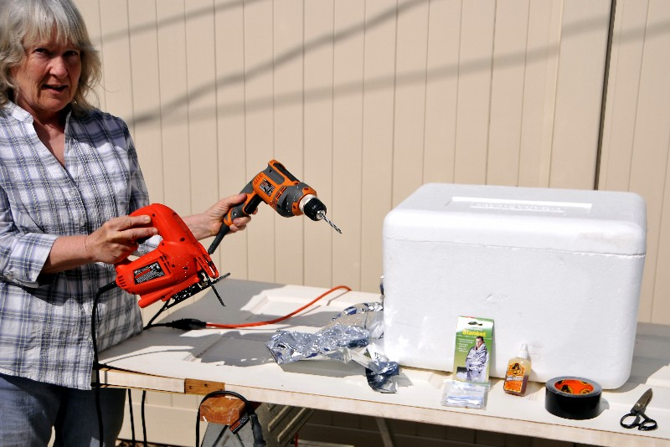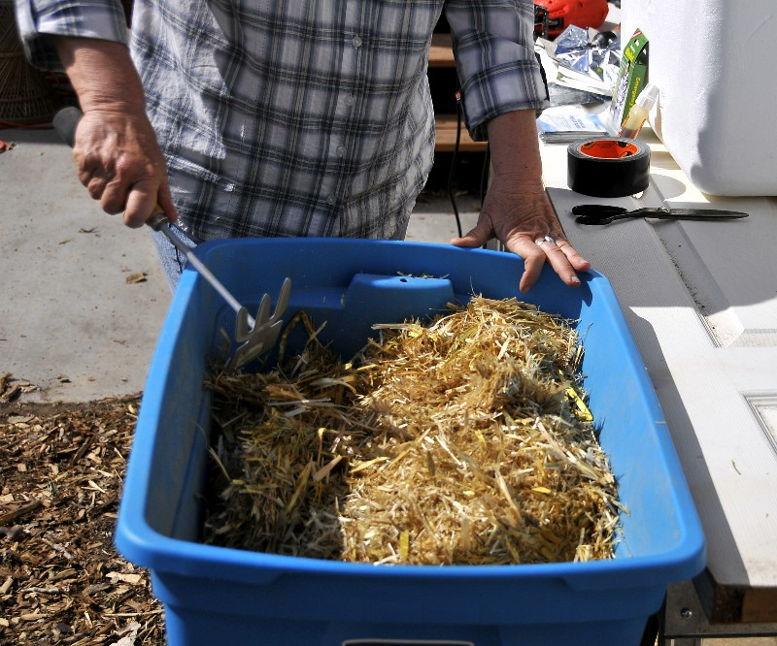

Cut a hole about 5 inches wide in the side of the container, near the top and near one end. 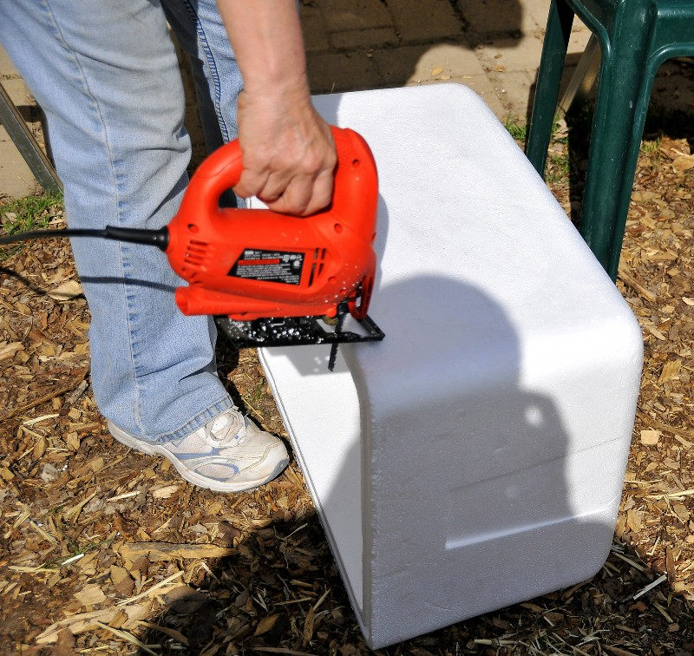 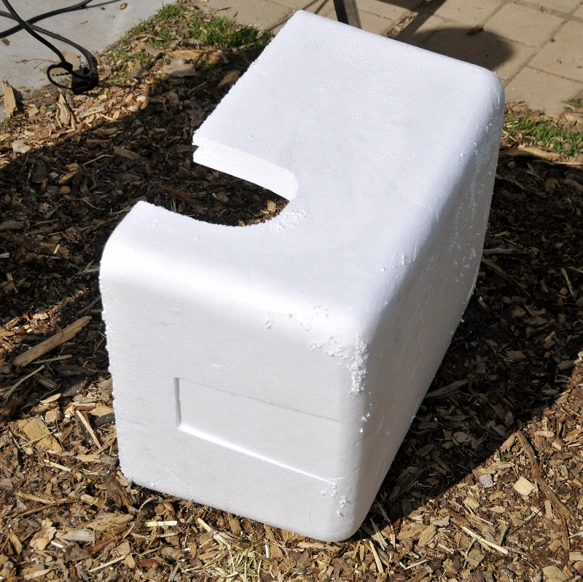

Drill a few small holes in the bottom of the container to allow condensation to drain out. Make sure the holes are free of Styrofoam bits so they will drain.
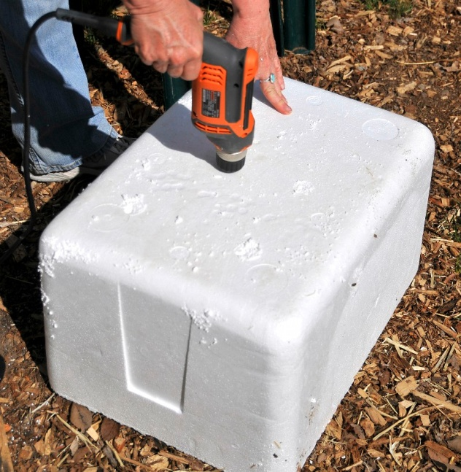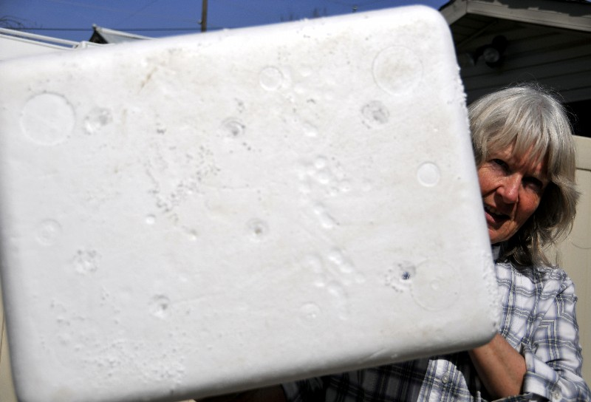

Fill the container to the top with loose straw (not hay, not blankets or cloth). The straw will compress so fill the container loosely. Straw is cheap and it makes the best bedding for cats to burrow in and stay warm. Make sure to press straw into the corners. Press the straw down a bit and away from the hole to allow room for the cat(s) to enter.
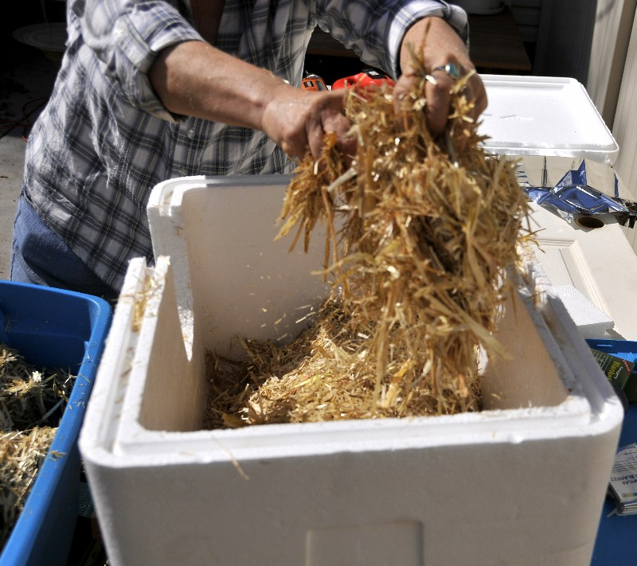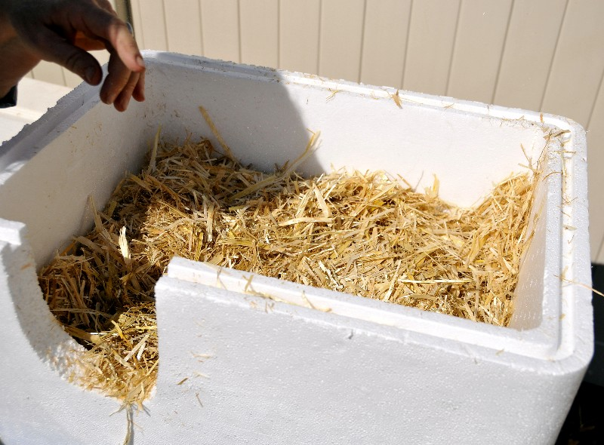

Using a foil emergency blanket, cut a piece to fit on the inside of the lid. Glue it to the inside of the lid to reflect the cat’s body heat back down to it.
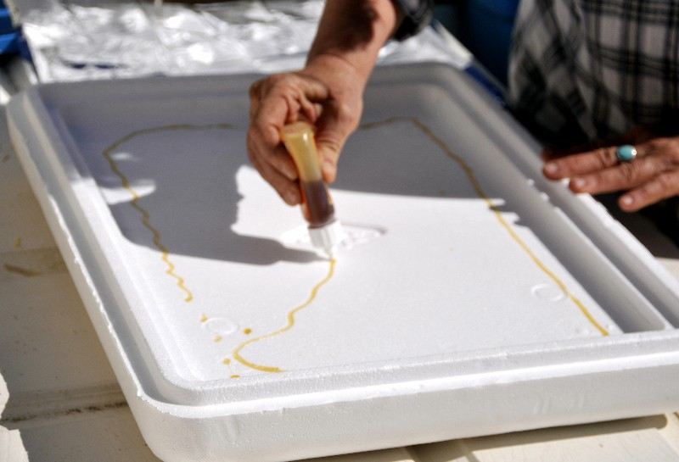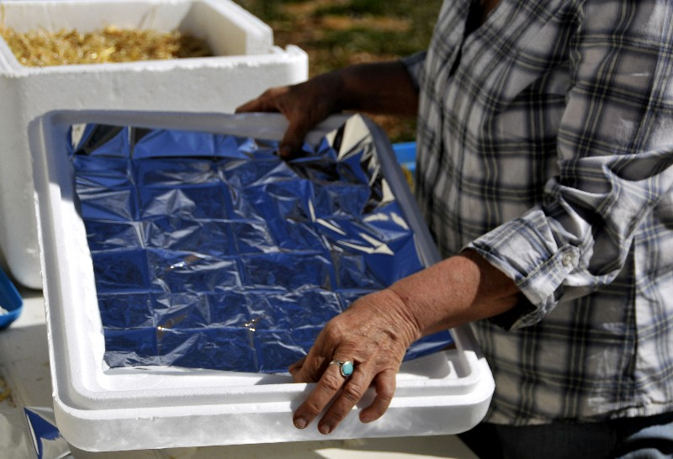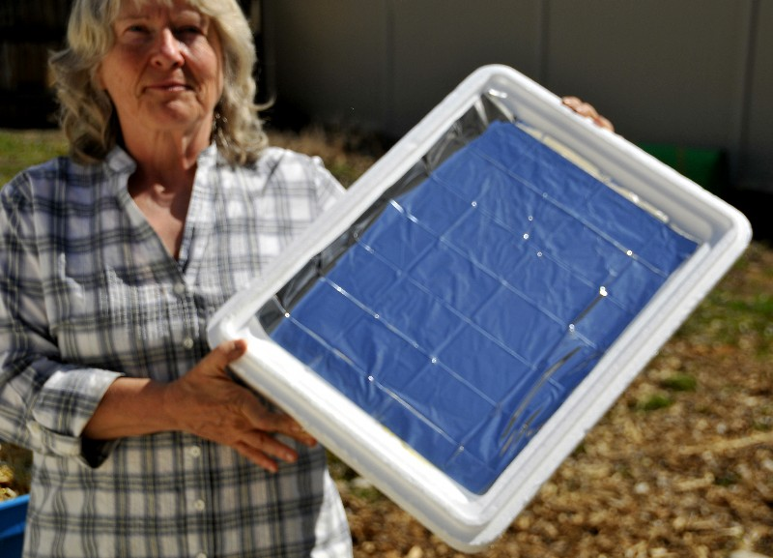

Using strong duct tape, tape the lid shut. Make sure it’s on tight. Press hard and rub the tape all around to get the best possible seal. It would be a good idea to tape around the entire container vertically, to assure the lid stays on.
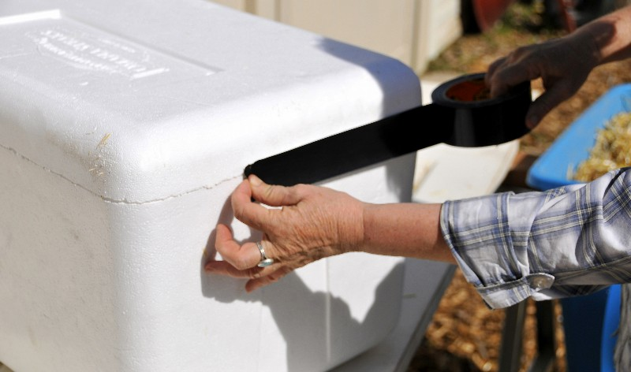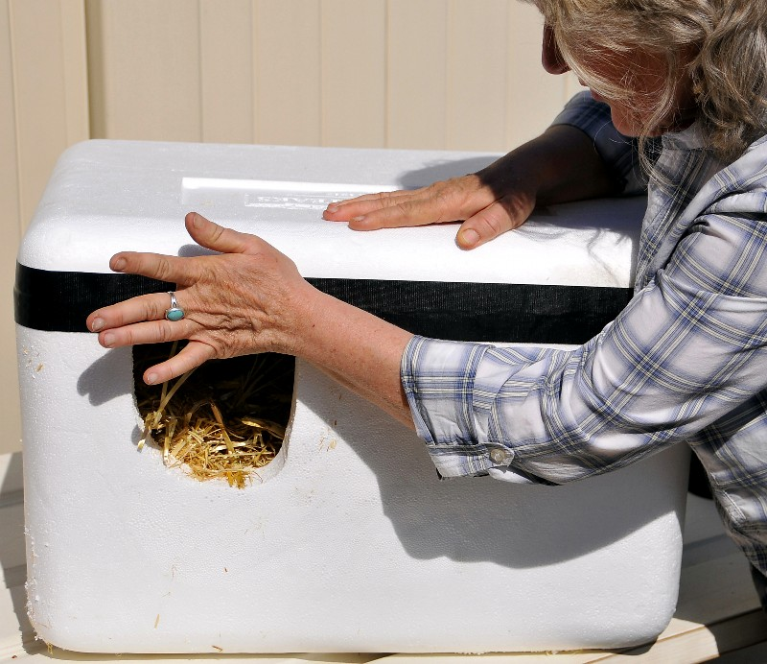

Cut a piece of heavy plastic sheeting that fits over the door and tape it to the top of the door to create a flap for the opening.
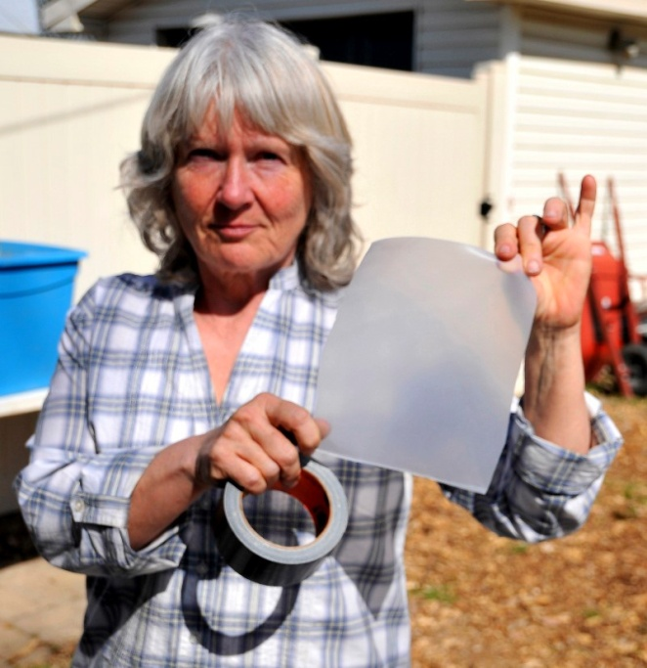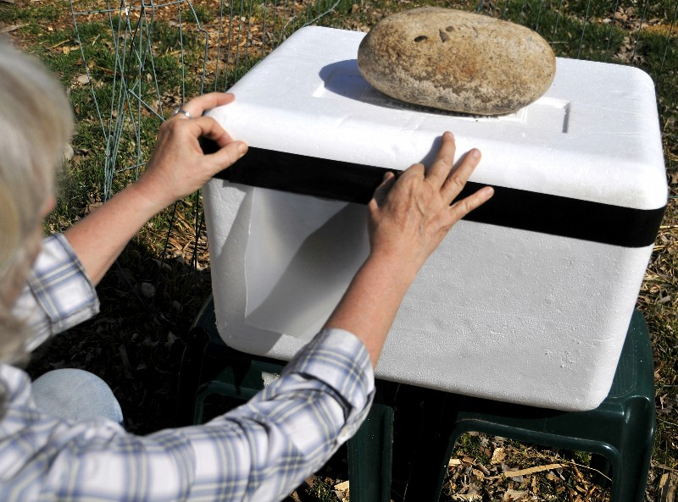
Place the shelter where the cats can get into it easily, but if possible, where dogs and other intruders can’t reach it. Cats like to be up high so if you can place it securely off the ground but where the cats can still easily get to it in snowy weather, that is best.
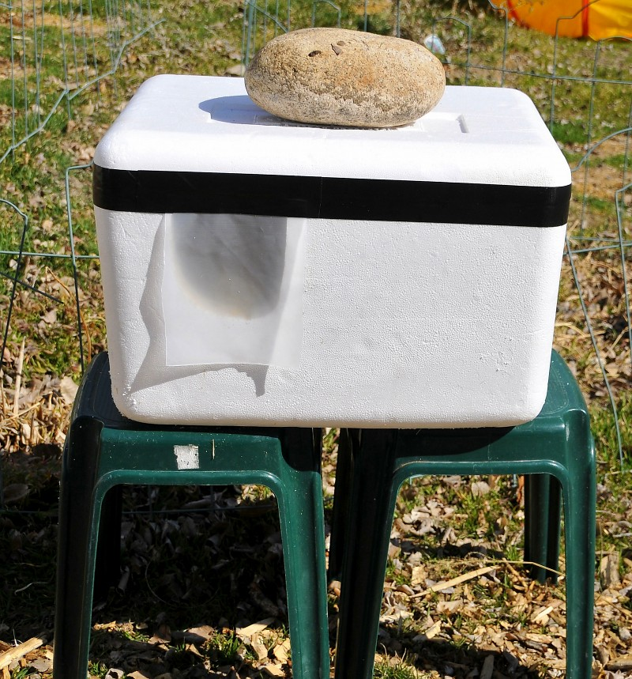

VERY IMPORTANT: Shelter will be very light-weight. It must be anchored or it will blow away. Either tie it down and stake the ties so it can’t blow away or place something heavy on the top of the shelter—but not too heavy. You don’t want to create a hazard for the cats or crush the shelter.
In the fall, check the shelter. If it’s still structurally sound, just remove the old straw and replace it with new straw. You may need to cut the lid off and retape it in order to replace the straw.
Styrofoam containers can be obtained from businesses that receive live or biological shipments: labs and hospitals, aquarium/fish stores, etc. They are also available from people who order items that must be shipped refrigerated, such as steaks or other food.

